TRANSPORT CARRIER SERVICES
IMPORTANT
YOUR CURRENT PHONE NUMBER
(______)_______-___________
E-Mail Address (please verify)

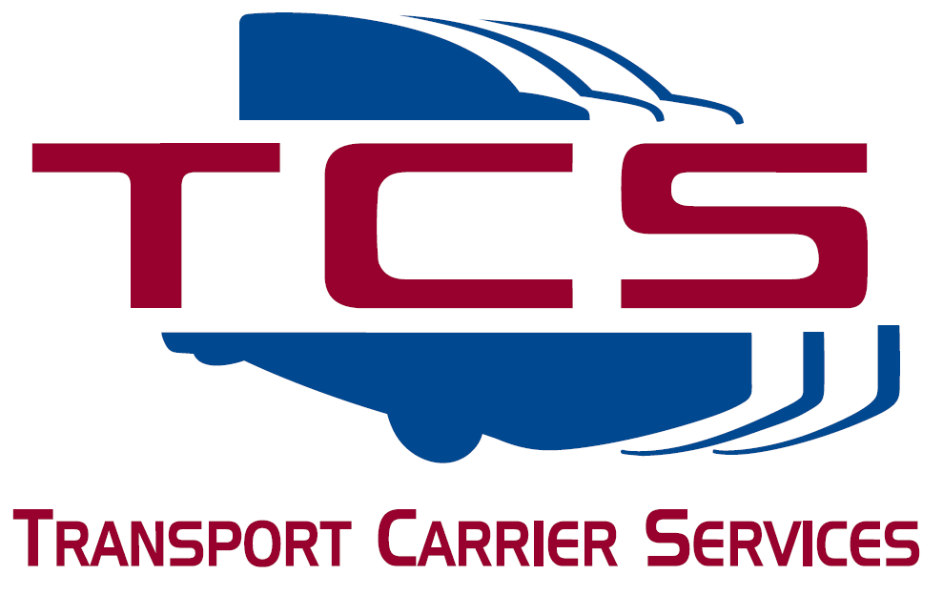
P O Box 14650
Phoenix AZ 85063-4650

Phone: 623-937-9869 Fax: 623-934-4548
Email: IRP@TCSPhoenix.com

2024/2025 JUNE IRP RENEWAL

Company Name: | #:
Are you leased to another company? No________
If yes, please give company name_________________________________________________& USDOT#_____________________
According to our records, your fleet IRP will expire June 30, 2024. This form should be completed and returned to TCS as soon as possible to assure an accurate and timely renewal. You can mail, fax, or e-mail this form back to our office. Please read all notes and directions carefully. If you have questions, feel free to give us a call.
US DOT# (please verify)

GRACE PERIOD:
ADOT will not issue any grace period beyond the June 30th expiration.

STATE MILES NEEDED:
The mileage time period for the June renewal will be from July 1, 2022, to June 30, 2023. You will need to provide total miles traveled in each state during this period for all power units in operation during this time period (apportioned only). If TCS has filed your IFTA taxes during this period, we should already have this information for you. If TCS did not file your IFTA taxes, you must provide the mileage information to us. TCS will declare actual miles and registration for the states traveled in the prior year to minimize registration costs.
INFORMATION NEEDED FOR RENEWAL:
- Please provide an equipment list of vehicles (trucks) that need to be renewed. Your trailers should already have AZ permanent plates. You can write on the back of this sheet or attach a second sheet. Do not assume that TCS knows what vehicles you need renewed.
- Please provide a copy of your validated "2290" (2023/2024) tax receipt from the IRS for any taxable power units. The IRS may take up to a month to return the receipt to you. Do not wait for the receipt before you return this form to TCS. We will start the renewal process without it. If TCS processes your 2290 tax forms and payments, we will already have a copy in our office. If you are processing the 2290 tax forms and payments, you must maintain a copy of your 2290 schedule identifying the vehicles by VIN. This 2290 schedule copy plus your cancelled check (front and back) may also be used as proof of payment for ADOT purposes.

Effective January 1, 2015, all IRP accounts will be registered in all states under the new Full Reciprocity Plan (FRP).
All STATES will be displayed on the cab card(s).
Fleet registration beginning January 1, 2015, or later:
- Registrants will be subject to the new FRP provisions.
- The fleet will be registered in all states; registrants will not be required to select the states in which they intend to operate.
- Every state will be displayed on the cab card(s); registrants will only pay fees to those states where distance was accrued during the fleet’s July-June reporting period.
This will eliminate the need to add states to your registration during the year.

PERMITS
No permits other than fleet IRP will need to be renewed at this time. This renewal will involve the renewing of apportioned plates only.
All other permits will be renewed at the end of this year.

IMPORTANT NOTES: If you submit your renewal sheet to TCS for processing and then choose not to renew, TCS’s service fees will be assessed for processing the renewal and reversing ADOT’s invoice. IRP’s processing time is a minimum of 3 days. As we get closer to the expiration date, processing time increases significantly. ANY RENEWAL REQUESTS SUBMITTED AFTER JUNE 15TH WILL BE ASSESSED AN ADDITIONAL $25.00 PROCESSING FEE AND THERE IS NO GUARANTEE THAT ADOT WILL RELEASE CREDENTIALS BEFORE THE EXPIRATION DATE.

PRINT NAME:____________________________________________________________________DATE:_________________

SIGNATURE:____________________________________________________________________________________________

PLEASE COMPLETE BACK SIDE ALSO

